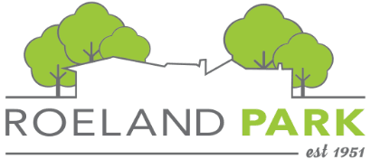

Agenda
Ad Hoc Strategic Planning Committee
June 9, 6 PM

- Review of Resident Survey Added Questions
  - Looking at the highlighted questions on the survey, are there specific questions you would add, change, or remove?
  - Any other comments or suggestions?
- Community Engagement Planning
  - What community engagement efforts have you been involved with that have been fruitful? What made them effective?
  - Committee feedback on three types of in-person engagement:

Engagement type | Logistics | Questions
One-on-one | Presence at community event | Which events? How can we make engagement successful in this setting?
Roundtables | Facilitated conversations with established groups | Which groups are most important? Virtual or in-person?
Open House | Established timeframe at civic location | Are people likely to attend? Has open house structure been used in the past? What would be an effective location?

What would make these types of engagement most successful? Are there any pitfalls or things to avoid?

- Next Steps
  - July 14 meeting:
    - Review outputs from Discovery Process
    - Refine community engagement calendar

